Work plan

Deadlines
- 2017-02-27 Choose a project proposal and send your choice via email to epsatisep@gmail.com
- 2017-03-06 Define the Tasks (what must be done - all members must participate in all tasks), subtask allocation (who does what) and Gantt chart (when) of the project and insert them on the wiki (planning)
- 2017-03-13 Upload the “black box” System Diagrams & Structural Drafts to the wiki
- 2017-03-27 Upload the detailed System Schematics & Structural Drawings to the wiki and finish the cardboard scale model of the structure
- 2017-04-03 Upload the List of Materials (what & quantity) to the wiki
- 2017-04-09 Upload the Interim Report and Presentation to the wiki. The report must contain the Introduction, including the tasks, team members allocation and Gantt chart, State of the Art, Marketing Plan, Project Management, Eco-eficiency Measures for Sustainability, Ethical and Deontological Concerns, Proposed Solution and Bibliography chapters
- 2017-04-24 Complete the List of Materials (local providers & price - including VAT and transportation) to the wiki
- 2017-04-20 Interim Presentation, Discussion and Peer, Teacher and Supervisor Feedbacks
- 2017-05-02 Upload refined Interim Report (based on Teacher & Supervisor Feedbacks)
- 2017-06-05 Upload the Functional Tests' Results to the wiki
- 2017-06-18 Upload the Final Report, Presentation, Video, Paper, Poster and Manual
- 2017-06-22 Final Presentation, Individual Discussion and Assessment
- 2017-06-26:
  - Update the wiki with all correction suggestions
  - Hand in to the EPS coordinator a CD with the corrected deliverables (source + PDF) together with all code and drawings produced
  - Hand in one printed exemplar of the corrected report to the EPS coordinator
- 2017-06-29:
  - Hand in the prototype and user manual to the client
  - Receive the EPS@ISEP certificate

Tasks
In chapter 1.7 you can see the task allocation of the Team.

Gantt Chart
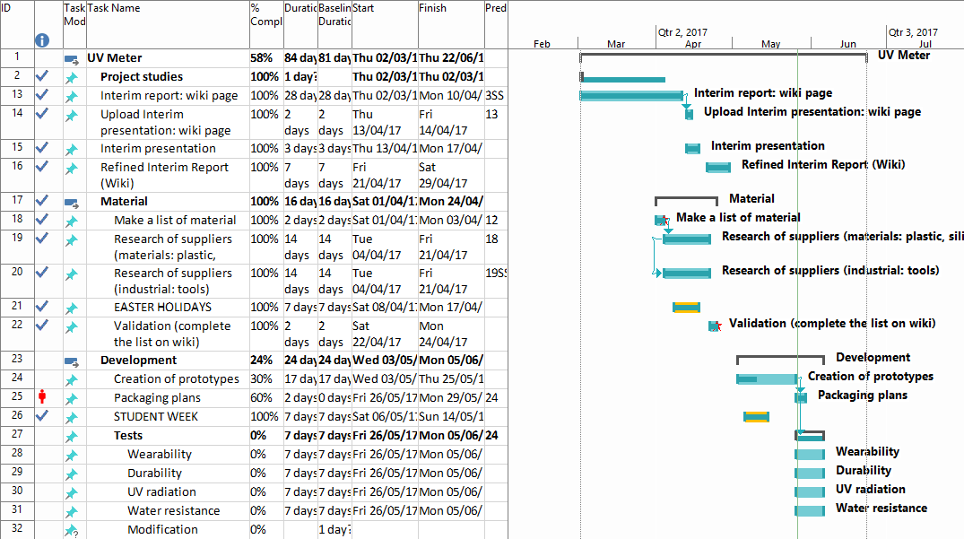
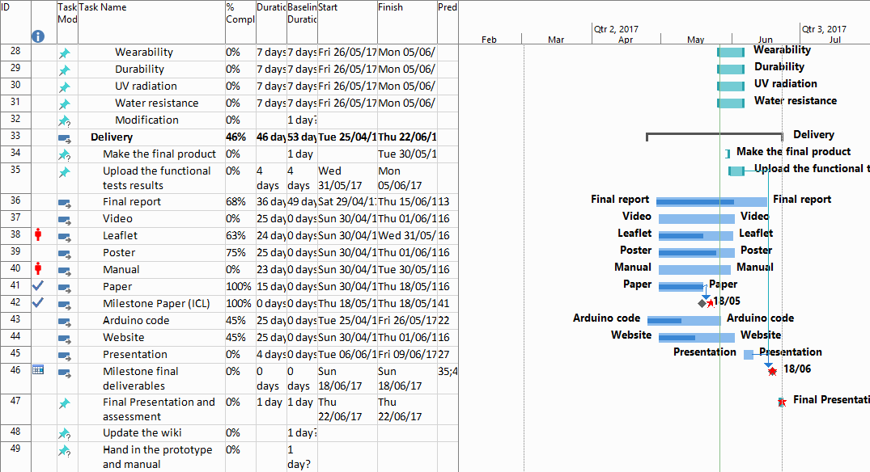
Quick view of our gantt:

System diagrams & structural drafts
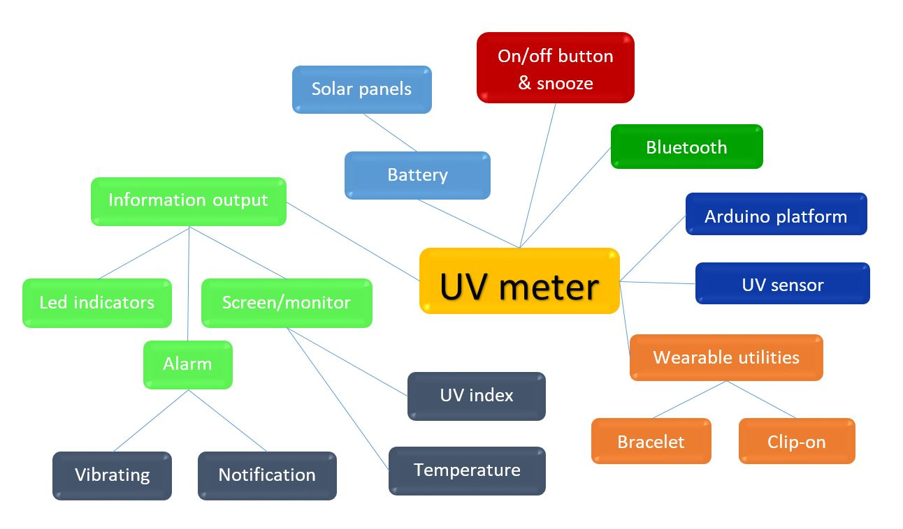
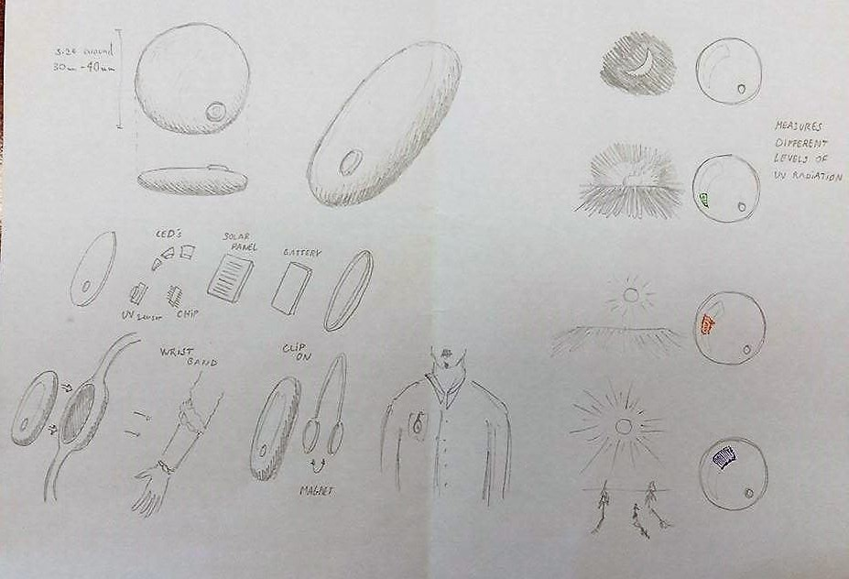
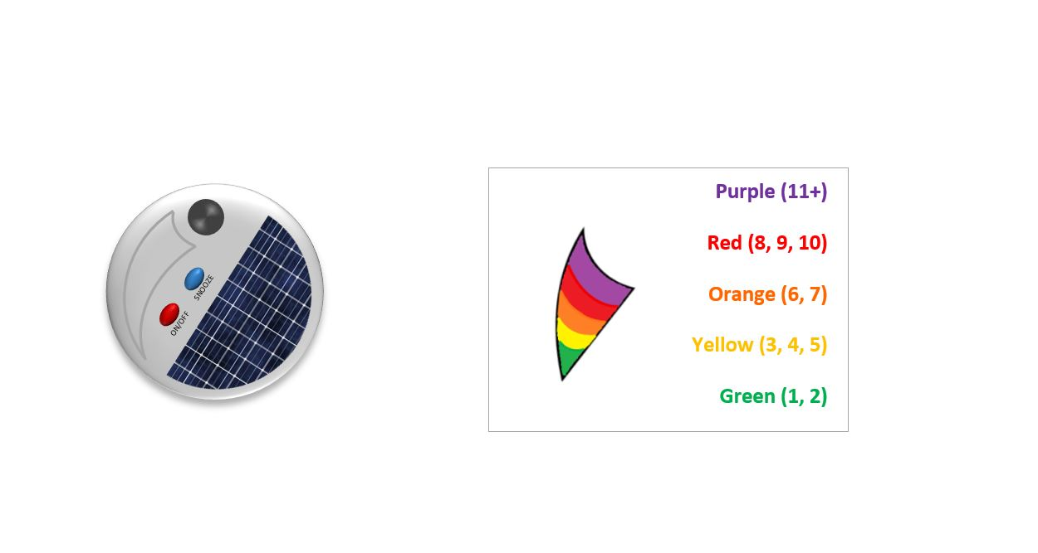

List of material


